Theme | Snack Person | Monday | Wednesday | Friday
 |  | 8 | 10  Open House | 12  Bring your favorite stuffed animal or toy
Red & Circle |  | 15  Bring small show and tell item in bag (sent home Friday) | 17  Wear red and bring a circle | 19  Find a red object at your house and bring it in.
Yellow & Triangle |  | 22  Wear yellow and bring a triangle | 24  Find a blue object at your house and bring it in. | 26  Make a triangle in a creative way.
Blue & Square |  | 29  Wear blue and bring a picture of something blue | 1  Bring a small square | 3  Bring a big, blue toy
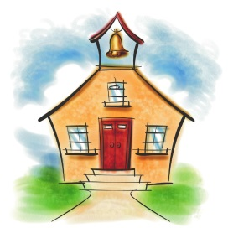
September

